***Data Warehouse & Data Mining Lab Task***



***Lab Task***

***Submitted by:*** *M.Umair Khan (FA21-BSE-070)*

***Submission Date***

*|21 March, 2025|*

**DWH Lab Tasks**

**Lab Task 3:**

**Matplotlib Library Code and Explain:**

# Step 1: Load and Explore

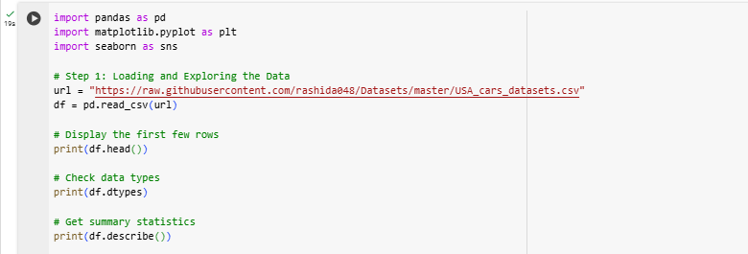

# Step 2: Perform Data Transform

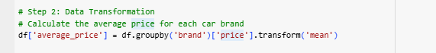

# Step 3: Analyze the Imapct of Demographic on Performance

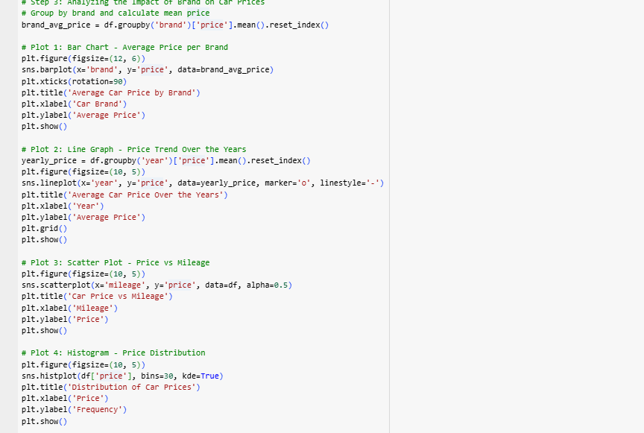

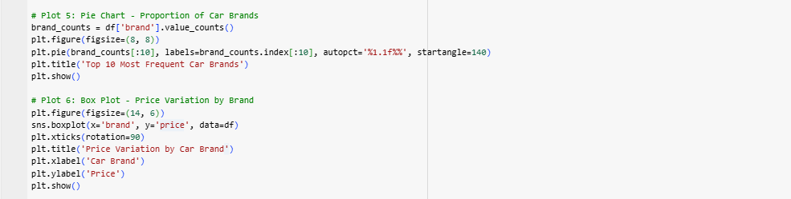

# Step 4: Exprected Output



